**Register Number: 2117033**

**Program Number: 20**

**Date: 01-03-2023**

**Program Name: Create an ASP.NET Website that performs CRUD Operations using**

**LINQ to SQL with appropriate validation and AJAX.**

**_______________________________________________________________________________________**

**homepage.aspx.cs**

using System;

using System.Collections.Generic;

using System.Linq;

using System.Web;

using System.Web.UI;

using System.Web.UI.WebControls;

namespace linqtosql{

public partial class homepage : System.Web.UI.Page{

protected void Page_Load(object sender, EventArgs e)

{ }

protected void insert_Click(object sender, EventArgs e){

Response.Redirect("insert.aspx");

}

protected void delete_Click(object sender, EventArgs e){

Response.Redirect("delete.aspx");

}

protected void update_Click(object sender, EventArgs e){

Response.Redirect("update.aspx");

}

protected void retrieve_Click(object sender, EventArgs e){

Response.Redirect("retrieve.aspx");

}

}

}

**insert.aspx.cs**

using System;

using System.Collections.Generic;

using System.Linq;

using System.Web;

using System.Web.UI;

using System.Web.UI.WebControls;

namespace linqtosql{

public partial class insert : System.Web.UI.Page{

protected void Page_Load(object sender, EventArgs e){ }

protected void insert_Click(object sender, EventArgs e){

using (DataClasses1DataContext db = new DataClasses1DataContext()){

tb1_Employee emp = new tb1_Employee(){

emp_name = TextBox1.Text,

emp_email = TextBox2.Text,

emp_dept = TextBox3.Text,

emp_yoe = int.Parse(TextBox4.Text)

};

db.tb1_Employees.InsertOnSubmit(emp);

db.SubmitChanges();

}

Response.Redirect("retrieve.aspx");

}

protected void back_Click(object sender, EventArgs e){

Response.Redirect("homepage.aspx");

}

protected void retrieve_Click(object sender, EventArgs e){

Response.Redirect("retrieve.aspx");

}

}

}

**retrieve.aspx.cs**

using System;

using System.Collections.Generic;

using System.Linq;

using System.Web;

using System.Web.UI;

using System.Web.UI.WebControls;

namespace linqtosql{

public partial class retrieve : System.Web.UI.Page{

protected void Page_Load(object sender, EventArgs e){

using (DataClasses1DataContext db = new DataClasses1DataContext()){

var query = from row in db.tb1_Employees select row;

GridView1.DataSource = query;

GridView1.DataBind();

};

}

protected void back_Click(object sender, EventArgs e){

Response.Redirect("homepage.aspx");

}

}

}

**delete.aspx.cs**

using System;

using System.Collections.Generic;

using System.Linq;

using System.Web;

using System.Web.UI;

using System.Web.UI.WebControls;

namespace linqtosql

{

public partial class delete : System.Web.UI.Page

{

protected void Page_Load(object sender, EventArgs e)

{

if (!IsPostBack)

{

using (DataClasses1DataContext db = new DataClasses1DataContext())

{

var query = from row in db.tb1_Employees select row;

ddl_select.DataSource = query;

ddl_select.DataTextField = "emp_name";

ddl_select.DataValueField = "emp_id";

ddl_select.DataBind();

ddl_select.Items.Insert(0, new ListItem("Select an employee"));

}

}

}

protected void back_Click(object sender, EventArgs e){

Response.Redirect("homepage.aspx");

}

protected void retrieve_Click(object sender, EventArgs e){

Response.Redirect("retrieve.aspx");

}

protected void DropDownList1_SelectedIndexChanged(object sender, EventArgs e){

int emp_id = int.Parse(ddl_select.SelectedValue);

using (DataClasses1DataContext db = new DataClasses1DataContext()){

var query = (from row in db.tb1_Employees where row.emp_id == emp_id select row).First();

TextBox1.Text = query.emp_name;

TextBox2.Text = query.emp_email;

TextBox3.Text = query.emp_email;

TextBox4.Text = query.emp_yoe + "";

}

}

protected void delete_Click(object sender, EventArgs e){

int emp_id = int.Parse(ddl_select.SelectedValue);

using (DataClasses1DataContext db = new DataClasses1DataContext()){

var query = (from row in db.tb1_Employees where row.emp_id == emp_id select row).First();

db.tb1_Employees.DeleteOnSubmit(query);

db.SubmitChanges();

}

Response.Redirect("retrieve.aspx");

}

}

}

**update.aspx.cs**

using System;

using System.Collections.Generic;

using System.Linq;

using System.Web;

using System.Web.UI;

using System.Web.UI.WebControls;

namespace linqtosql{

public partial class update : System.Web.UI.Page{

protected void Page_Load(object sender, EventArgs e){

if (!IsPostBack){

using (DataClasses1DataContext db = new DataClasses1DataContext()){

var query = from row in db.tb1_Employees select row;

ddl_select.DataSource = query;

ddl_select.DataTextField = "emp_name";

ddl_select.DataValueField = "emp_id";

ddl_select.DataBind();

ddl_select.Items.Insert(0, new ListItem("Select an employee"));

}

}

}

protected void update_Click(object sender, EventArgs e){

int emp_id = int.Parse(ddl_select.SelectedValue);

using (DataClasses1DataContext db = new DataClasses1DataContext()){

tb1_Employee emp = (from row in db.tb1_Employees where row.emp_id == emp_id select row).First();

emp.emp_name = TextBox1.Text;

emp.emp_email = TextBox2.Text;

emp.emp_dept = TextBox3.Text;

emp.emp_yoe = int.Parse(TextBox4.Text);

db.SubmitChanges();

}

Response.Redirect("retrieve.aspx");

}

protected void back_Click(object sender, EventArgs e){

Response.Redirect("homepage.aspx");

}

protected void retrieve_Click(object sender, EventArgs e){

Response.Redirect("retrieve.aspx");

}

protected void ddlSelect_SelectedIndexChanged(object sender, EventArgs e){

int emp_id = int.Parse(ddl_select.SelectedValue);

using (DataClasses1DataContext db = new DataClasses1DataContext()){

var query = (from row in db.tb1_Employees where row.emp_id == emp_id select row).First();

TextBox1.Text = query.emp_name;

TextBox2.Text = query.emp_email;

TextBox3.Text = query.emp_email;

TextBox4.Text = query.emp_yoe + "";

}

}

}

}

**OUTPUT**

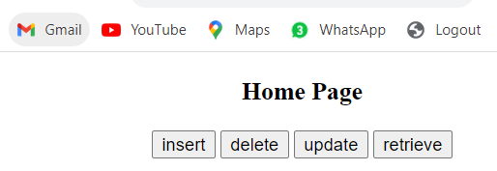

**Insert**

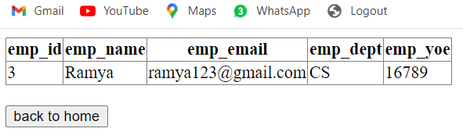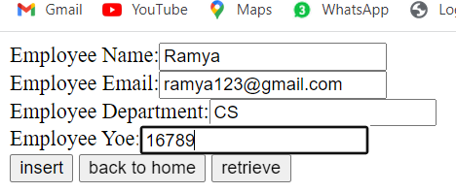

**Update:**

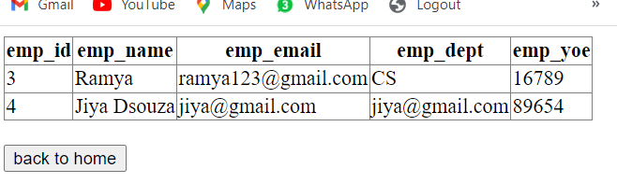

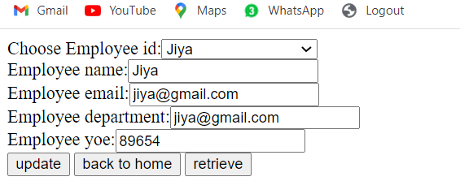

**Delete:**

